How to Make a Python Package Available via PIP

Peter Rochford
rochford.peter1@gmail.com

Created: 12/26/2016
Revised: 12/22/2025

Table of Contents
Purpose 2
Step 1: Structure Your Project 2
Step 2: Write the setup.py File 3
Step 3: Create a PyPI Account 5
Step 4: Install Packaging Tools 6
Step 5: Create the Distribution Package 6
Step 6 (Recommended): Upload the Package to TestPyPI 7
Step 7 (Recommended): Install Your Package from TestPyPI 8
Step 8: Upload the Package to PyPI 8
Step 9: Install Your Package 8
Project Files 9
README.md 9
Creating a LICENSE 9
Releasing New Versions of Pip Package 9
Troubleshooting 10
No module named twine 10
SSLError 11
Filename has already been used 12
File already exists 12
FileNotFoundError UserDict.py 13
HTTPError: 400 Bad Request from https://test.pypi.org/legacy/ 14

Purpose
These notes describe the steps taken to make the SkillMetrics Python library available to the Python community via the Python Packaging Index (PyPI). Creating a Python package and publishing it to PyPI allows others to easily install it using pip. Here's a step-by-step guide to help you package your GitHub project and make it available on PyPI. More information can be found at Packaging Python Projects.

Step 1: Structure Your Project
Ensure that your project has the following structure:
- your_package is the directory that contains your Python package code.
- __init__.py is an empty file that tells Python that this directory should be considered a Python package.
- setup.py is the script for building, distributing, and installing modules.
- README.md contains information about your project.
- LICENSE.txt contains the license information.
A suggested minimal project structure to use is:
YourPackage/
├── LICENSE.txt
├── README.md
├── setup.py
├── your_package /
│ ├── __init__.py
│ └── example.py
└── tests/
The project structure currently used for the SkillMetrics project is:
SkillMetrics
├── Documents/
│ └── PIP notes.docx
├── LICENSE.txt
├── README.md
├── Examples/
│ ├── all_stats.py (calculate all skill metrics)
│ ├── target*.py (target diagram examples)
│ └── target*.py (Taylor diagram examples)
├── skill_metrics
│ ├── __init__.py
│ └── *.py (source files)
└── Test/

Step 2: Write the setup.py File
Create a setup.py file at the root of your project with the following content.
from setuptools import setup, find_packages
setup(
name='my_package',
version='0.1',
packages=find_packages(),
install_requires=[
'numpy',
'pandas'
],
author='Your Name',
author_email='your.email@example.com',
description='A short description of your project.',
long_description=open('README.md').read(),
long_description_content_type='text/markdown',
url='https://github.com/your_user_name/your_project_name',
classifiers=[
'Development Status :: 4 - Beta',
'Intended Audience :: Developers',
'License :: OSI Approved :: GNU General Public License v3 (GPLv3)',
'Programming Language :: Python :: 3.14',
],
)
Modify the content as needed for your project. Replace placeholders like your_project_name and Your Name with the actual details of your project. Accepted values of classifiers can be found at pypi.org/classifiers. Make sure to test your package locally before publishing it to PyPI to ensure everything works as expected. For the SkillMetrics package the following setup.py file is used.
'''
A script to create a pip release of the SkillMetrics package.

Description of the package can be found in the wiki:
https://github.com/PeterRochford/SkillMetrics/wiki

Created on Aug 22, 2023
Revised on Dec 19, 2025

@author: Peter Rochford
'''
from setuptools import setup, find_packages

setup(
name='SkillMetrics',
version='1.2.5',
packages=find_packages(),
install_requires=[
'matplotlib',
'numpy',
'pandas',
'xlsxwriter'
],
author='Peter Rochford',
author_email='rochford.peter1@gmail.com',
description='A Python library for calculating and displaying the skill of model predictions against observations.',
long_description=open('README.md').read(),
long_description_content_type='text/markdown',
url='https://github.com/PeterRochford/SkillMetrics/tree/master',
classifiers=[
'Development Status :: 4 - Beta',
'Intended Audience :: Developers',
'License :: OSI Approved :: GNU General Public License v3 (GPLv3)',
'Programming Language :: Python :: 3.14',
],
)

Step 3: Create a PyPI Account
If you don't have a PyPI or testPyPI account, create one at pypi.org and test.pypi.org, respectively.
API tokens are required to upload packages to both TestPyPI and the main PyPI, especially since two-factor authentication (2FA) is now required for management actions. Basic username and password authentication is no longer sufficient in most cases. PyPI has enforced 2FA for all user accounts since January 1, 2024, and requires secure authentication methods for uploads. Using an API token is the current standard practice for secure publishing. To set up an API token refer to Learn more about API tokens, setting the “Scope” to “Entire account”. Don’t close the page until you have copied and saved the token — you won’t see that token again.
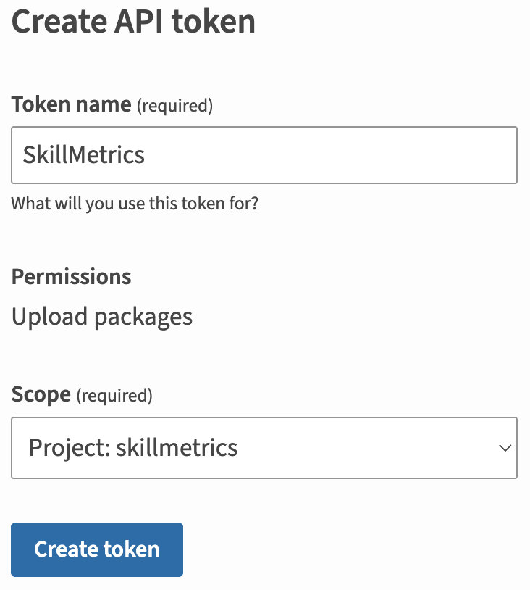
Create a .pypirc file to enable uploads to the PyPI site. Instructions on how to create one can be found on the Python Packaging User Guide. For example, for the SkillMetrics package, we use:
[distutils]
index-servers =
pypi
testpypi

[pypi]
username: __token__
password: <PyPI token>

[testpypi]
repository: https://test.pypi.org/legacy/
username: __token__
password: <TestPyPI token>

Step 4: Install Packaging Tools
Install the required tools to build and distribute your package:
pip install setuptools
pip install twine
You need to have setuptools installed to run setup.py. The setuptools package provides the infrastructure for building and distributing Python packages. It includes the setup() function that is used in the setup.py file to define the package metadata and dependencies.
You need twine to upload Python packages to PyPI. It provides a secure and reliable way to upload your package and make it available for others to install using pip.

Step 5: Create the Distribution Package
Navigate to your project directory and run the following command:
% python3 -m build
* Creating isolated environment: venv+pip...
* Installing packages in isolated environment:
- setuptools >= 40.8.0
* Getting build dependencies for sdist...
…
adding 'skillmetrics-1.2.5.2.dist-info/RECORD'
removing build/bdist.macosx-10.15-universal2/wheel
Successfully built skillmetrics-1.2.5.2.tar.gz and skillmetrics-1.2.5.2-py3-none-any.whl
This will create the distribution package in the dist directory. This command should output a lot of text and once completed should generate two files in the dist directory. Before uploading, check the newly created files in the dist directory.
% python -m twine check dist/*
Checking dist/skillmetrics-1.2.5.2-py3-none-any.whl: PASSED
Checking dist/skillmetrics-1.2.5.2.tar.gz: PASSED
For a linux operating system:
% ls -1 dist
SkillMetrics-1.0.1.tar.gz
SkillMetrics-1.0.1-py3-none-any.whl
You can examine the contents of the tarball (compressed archive file *.tar.gz) to see if it contains all the required files:
% cd ~/git/SkillMetrics/dist
% gunzip SkillMetrics-1.2.4.tar.gz
% tar tvf SkillMetrics-1.2.4.tar | more
For a Windows operating system:
> dir dist
Volume in drive C is OS
Volume Serial Number is 2A0E-F20E

Directory of C:\Users\Peter Rochford\git\SkillMetrics\dist
…
08/25/2023 11:08 AM 40,902 SkillMetrics-1.0.1-py3-none-any.whl
08/25/2023 11:08 AM 24,630 SkillMetrics-1.0.1.tar.gz
…
When you run the setup.py script it will create two types of distribution packages:
- Source Distribution (sdist): This is a compressed archive of your source code and can be used by users who want to build the package from source.
- Wheel Distribution (bdist_wheel): This is a pre-built binary distribution, and it's what most users will install. Wheel distributions are generally faster to install and can include compiled extensions.
The filenames will include the package name, version number, and extensions like *.tar.gz (for the source distribution) and *.whl (for the wheel distribution).

Step 6 (Recommended): Upload the Package to TestPyPI
Once you have built a distribution package, you should check its contents to make sure that everything is included and there are no errors or missing files. You can do this by extracting the contents of the *.tar.gz file (for source distributions) or *.whl file (for wheel distributions) and checking that all files are present. For this step it is recommended you use a 4-digit version number such as version='1.0.0.X' as you may need to make several attempts where X is incremented several times before you have something you wish to upload to PyPI as version='1.0.0'. The reason is you can’t upload a new pip package to PyPI or TestPyPI using the same version number as described further below.
If everything is good, you can upload your package to PyPI using twine, which is a tool for uploading Python packages to PyPI. It is recommended you use TestPyPI before publishing to the main PyPI repository.
python3 -m twine upload --repository testpypi dist/*
For example, if uploading the SkillMetrics package, remove old *.tar.gz and *.whl files and check only the latest version is there:
% cd /Users/Peter/git/SkillMetrics
% ls -1 dist
skillmetrics-1.2.5.1-py3-none-any.whl
skillmetrics-1.2.5.1.tar.gz
% python3 -m twine upload --repository testpypi dist/*
Uploading distributions to https://test.pypi.org/legacy/
Uploading skillmetrics-1.2.5.1-py3-none-any.whl
100% ━━━━━━━━━━━━━━━━━━━━━━━━━━━━━━━━━━━━━━━━ 93.2/93.2 kB • 00:00 • 482.6 MB/s
Uploading skillmetrics-1.2.5.1.tar.gz
100% ━━━━━━━━━━━━━━━━━━━━━━━━━━━━━━━━━━━━━━━━ 69.3/69.3 kB • 00:00 • 143.0 MB/s

View at:
https://test.pypi.org/project/SkillMetrics/1.2.5.1/
Note that PyPI does not allow for the reuse of distribution filenames (project name + version number + distribution type). This ensures that a given distribution for a given release for a given project will always resolve to the same file and cannot be surreptitiously changed one day by the project’s maintainer or a malicious party (it can only be removed). You will need to change the version number to one that you haven’t previously uploaded to PyPI.

Step 7 (Recommended): Install Your Package from TestPyPI
After uploading your packages to TestPyPI, try installing them using pip from another virtual environment or machine. This will help ensure that installation works correctly for other users.
pip install -i https://test.pypi.org/simple SkillMetrics
If you are upgrading the package, then include the –upgrade option.
pip install -i https://test.pypi.org/simple SkillMetrics --upgrade

Step 8: Upload the Package to PyPI
If everything looks good on TestPyPI then do the following:
- Edit setup.py to have a 3-digit code, e.g. 1.2.4, rather than the 4-digit code that was used for the TestPyPI uploads, e.g. 1.2.4.2.
- Delete the files in dist/* and build again.
rm -i dist/*
python3 -m build
- Check that 3-digit versions have been created.
% ls -1 dist/*
dist/skillmetrics-1.2.4-py3-none-any.whl
dist/skillmetrics-1.2.4.tar.gz
- Upload the release to the PyPI server.
python3 -m twine upload dist/*
Be sure the new has a 3-digit code before uploading.
Note that PyPI does not allow for the reuse of distribution filenames (project name + version number + distribution type) as described in Step 6.

Step 9: Install Your Package
Once successfully uploaded, anyone (including yourself) can install your package with:
pip install SkillMetrics
This will generate a lot of output as shown below but once finished your GitHub project will be available on the target computer platform.
% pip install SkillMetrics
Defaulting to user installation because normal site-packages is not writeable
Collecting SkillMetrics
Downloading SkillMetrics-1.0.1-py3-none-any.whl (40 kB)
━━━━━━━━━━━━━━━━━━━━━━━━━━━━━━━━━━━━━━━━ 40.6/40.6 kB 3.8 MB/s eta 0:00:00
Collecting scipy
Downloading scipy-1.11.1-cp310-cp310-macosx_12_0_arm64.whl (29.6 MB)
━━━━━━━━━━━━━━━━━━━━━━━━━━━━━━━━━━━━━━━━ 29.6/29.6 MB 53.9 MB/s eta 0:00:00
Requirement already satisfied: matplotlib in /Library/Frameworks/Python.framework/Versions/3.10/lib/python3.10/site-packages (from SkillMetrics) (3.5.3)
Requirement already satisfied: numpy in /Library/Frameworks/Python.framework/Versions/3.10/lib/python3.10/site-packages (from SkillMetrics) (1.23.3)
Requirement already satisfied: pandas in /Library/Frameworks/Python.framework/Versions/3.10/lib/python3.10/site-packages (from SkillMetrics) (1.4.4)
Note that if you previously installed one of the versions from TestPyPI, then you will have to remove that version before installing from PyPI.
% pip show SkillMetrics
Name: SkillMetrics
Version: 1.2.5
Summary: A Python library for calculating and displaying the skill of model predictions against observations.
Home-page: https://github.com/PeterRochford/SkillMetrics/tree/master
Author: Peter Rochford
Author-email: rochford.peter1@gmail.com
License:
Location: /Users/Peter/git/SkillMetrics
Requires: matplotlib, numpy, pandas, xlsxwriter
Required-by:
% pip uninstall SkillMetrics
Found existing installation: SkillMetrics 1.2.5.2
Uninstalling SkillMetrics-1.2.5.2:
Would remove:
c:\users\p000980h\appdata\local\packages\pythonsoftwarefoundation.python.3.12_qbz5n2kfra8p0\localcache\local-packages\python312\site-packages\skill_metrics\*
c:\users\p000980h\appdata\local\packages\pythonsoftwarefoundation.python.3.12_qbz5n2kfra8p0\localcache\local-packages\python312\site-packages\skillmetrics-1.2.5.2.dist-info\*
Proceed (Y/n)? Y
Successfully uninstalled SkillMetrics-1.2.5.2
% pip install SkillMetrics
Defaulting to user installation because normal site-packages is not writeable
Collecting SkillMetrics
Downloading skillmetrics-1.2.5-py3-none-any.whl.metadata (6.9 kB)
…
Downloading skillmetrics-1.2.5-py3-none-any.whl (83 kB)
Installing collected packages: SkillMetrics
Successfully installed SkillMetrics-1.2.5
% pip show SkillMetrics
Finally, it is recommended you run the regression tests again to confirm everything is correct.
% python3 test_plots.py

Project Files

README.md
The project uses the Markdown file (README.md) which appears to be most popular for GitHub projects. A README.md was created that follows the outline used for the corresponding file in the SkillMetrics GitHub project.

Creating a LICENSE
It’s important for every package uploaded to the Python Package Index to include a license. A LICENSE.txt file containing a MIT License was created with the initial release of the SkillMetrics package in 2016.

Releasing New Versions of Pip Package
- To find the version of a currently installed SkillMetrics package, use the pip show command:
% pip show SkillMetrics
Name: SkillMetrics
Version: 1.2.4
Summary: A Python library for calculating and displaying the skill of model predictions against observations.
Home-page: https://github.com/PeterRochford/SkillMetrics/tree/master
Author: Peter Rochford
Author-email: rochford.peter1@gmail.com
License:
Location: /Users/Peter/git/SkillMetrics
Requires: matplotlib, numpy, pandas, xlsxwriter
Required-by:
- Next check what version has been currently uploaded to the Test PyPI site as this may differ from what has been released.
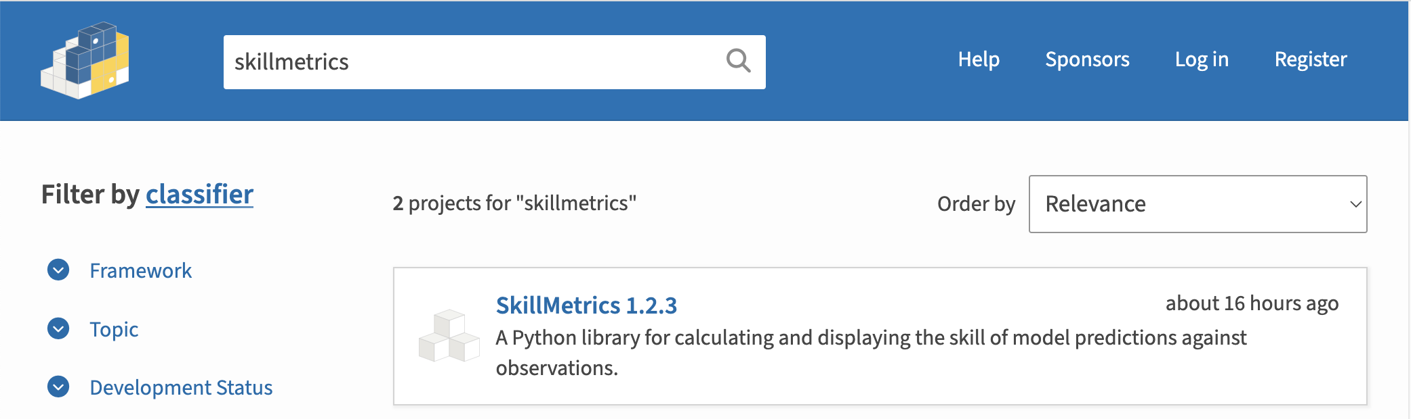
- Next follow Step 5 to 9 above create and release the latest version.
If you are creating the SkillMetrics package be sure to update the Test.zip and test_plots.py script in the GitHub folder Test. To create the former, simply update the list file of files that need to be included (Examples/test_zip_files.txt) and then run the script: Test/test_zip.sh.

Troubleshooting
This section contains many solutions for troubleshooting problems in creating a pip package release. While many of them refer to earlier processes using setuptools and twine they are retained for future reference if needed.

No module named twine

Problem
When trying to upload the SkillMetrics package I get the following error.

% python3 -m twine upload --repository testpypi dist/*
/Library/Frameworks/Python.framework/Versions/3.10/bin/python3: No module named twine

Solution
This occurs because the twine package is not installed.

% python3 -m pip install --upgrade twine
Collecting twine
Downloading twine-4.0.2-py3-none-any.whl (36 kB)
...

Installing collected packages: webencodings, zipp, rfc3986, Pygments, pkginfo, more-itertools, mdurl, docutils, bleach, requests-toolbelt, readme-renderer, markdown-it-py, jaraco.classes, importlib-metadata, rich, keyring, twine
Successfully installed Pygments-2.14.0 bleach-6.0.0 docutils-0.19 importlib-metadata-6.1.0 jaraco.classes-3.2.3 keyring-23.13.1 markdown-it-py-2.2.0 mdurl-0.1.2 more-itertools-9.1.0 pkginfo-1.9.6 readme-renderer-37.3 requests-toolbelt-0.10.1 rfc3986-2.0.0 rich-13.3.2 twine-4.0.2 webencodings-0.5.1 zipp-3.15.0

Filename has already been used

Problem
When trying to upload a new version of the Skill Metrics package I get the following error.
% python3 -m twine upload --repository-url https://test.pypi.org/legacy/ dist/*
Enter your username: PeterRochford
Enter your password:
Uploading distributions to https://test.pypi.org/legacy/
Uploading SkillMetrics-1.1.5-py2-none-any.whl
100%|█████████████████████████████████████████████████████████████████████████████████| 53.2k/53.2k [00:00<00:00, 72.7kB/s]
NOTE: Try --verbose to see response content.
HTTPError: 400 Client Error: This filename has already been used, use a different version. See https://test.pypi.org/help/#file-name-reuse for url: https://test.pypi.org/legacy/

Solution
This occurs because of the presence of old packages in the dist folder. Simply delete them or move them out of the folder.
% python3 -m twine upload --repository-url https://test.pypi.org/legacy/ dist/*
Enter your username: PeterRochford
Enter your password:
Uploading distributions to https://test.pypi.org/legacy/
Uploading SkillMetrics-1.1.6-py2-none-any.whl
100%|█████████████████████████████████████████████████████████████████████████████████| 57.7k/57.7k [00:00<00:00, 73.9kB/s]
Uploading SkillMetrics-1.1.6.tar.gz
100%|█████████████████████████████████████████████████████████████████████████████████| 49.1k/49.1k [00:01<00:00, 36.4kB/s]

File already exists

Problem
When trying to upload a replacement version of the Skill Metrics package I get the following error.
% sudo python3 -m twine upload --repository-url https://test.pypi.org/legacy/ dist/*
Uploading distributions to https://test.pypi.org/legacy/
Enter your username: PeterRochford
Enter your password:
Uploading SkillMetrics-1.1.8-py3-none-any.whl
100%|██████████████████████████████████████████████████████████████████████████████████| 69.5k/69.5k [00:00<00:00, 100kB/s]
NOTE: Try --verbose to see response content.
HTTPError: 400 Bad Request from https://test.pypi.org/legacy/
File already exists. See https://test.pypi.org/help/#file-name-reuse for more information.

Solution
This occurs because a file for that version already exists on the test.pypi.org site. Simply delete the packages from the site.

- Go to the SkillMetrics package:
https://test.pypi.org/manage/project/SkillMetrics/releases
- You'll see a listing like this one:
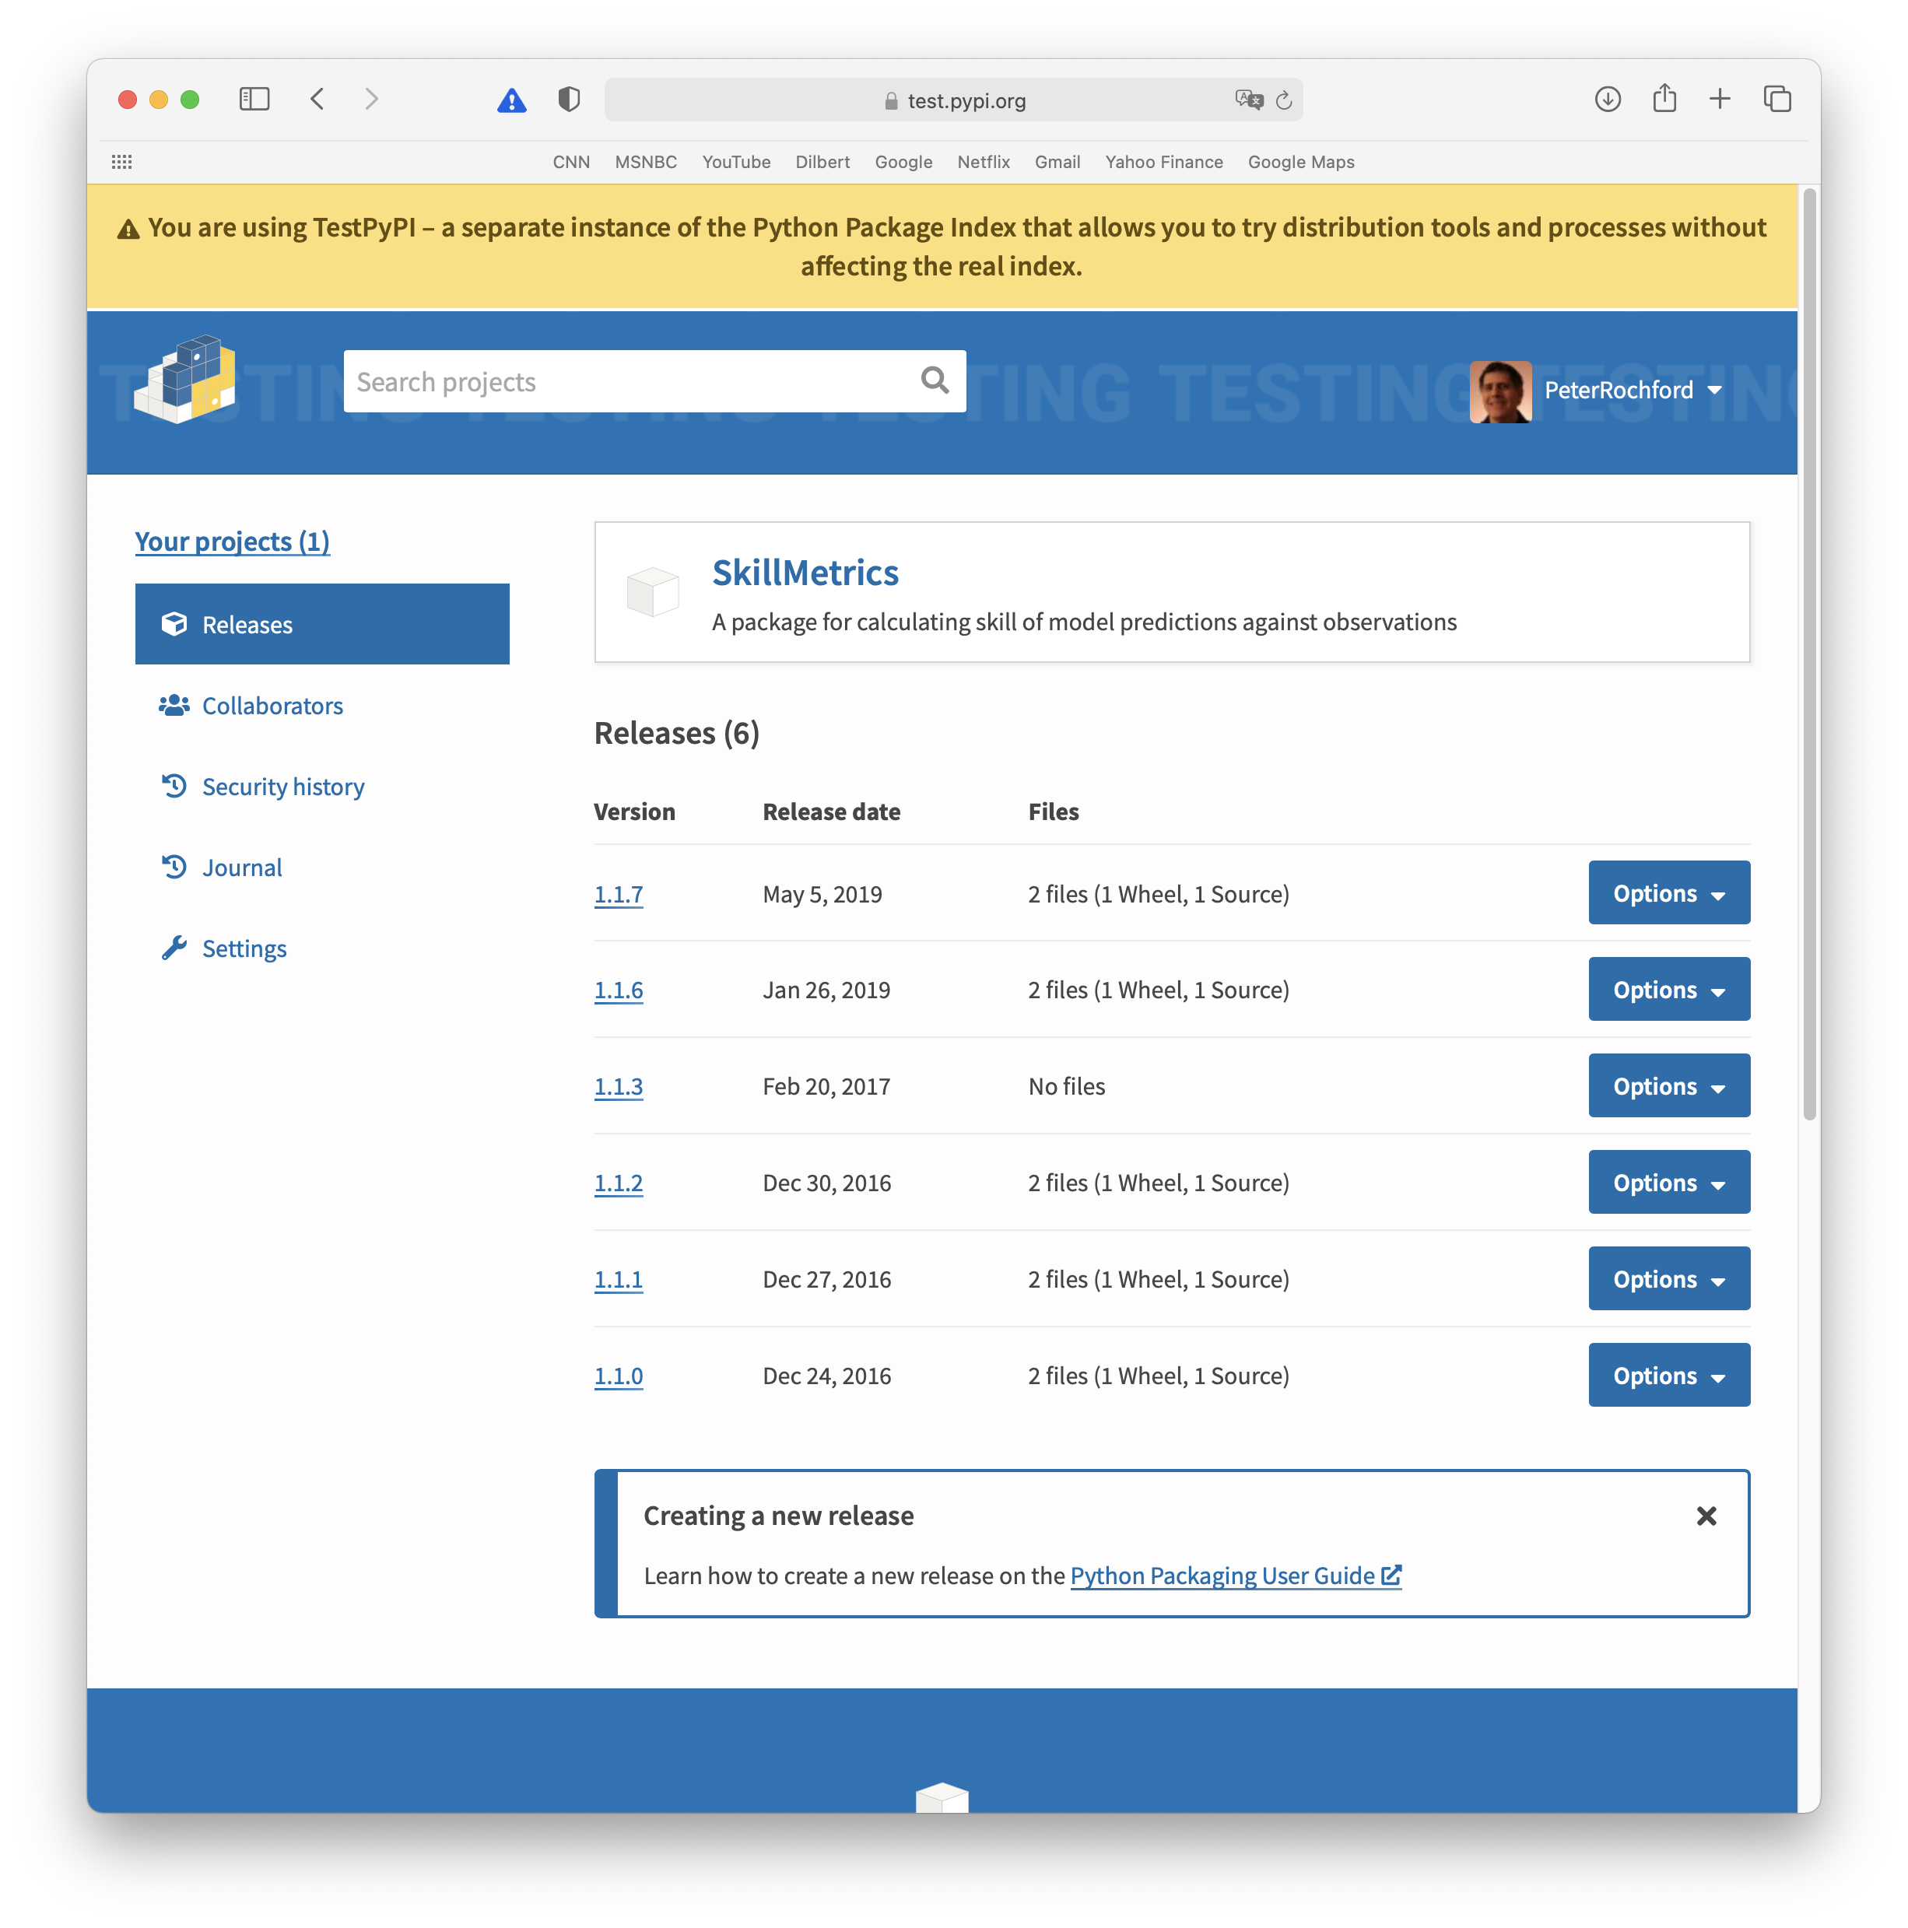
- Point to "options" and click on "delete".

